Exercise: Hanoi Tower

Do not search online for the solution to this problem but you can discuss it with other interns.

Difficulty level: 3 stars out of 5

There is only one player.

There are three sticks as shown below. These sticks can hold plates. These plates are not like normal plates because they have holes in the middle of them.

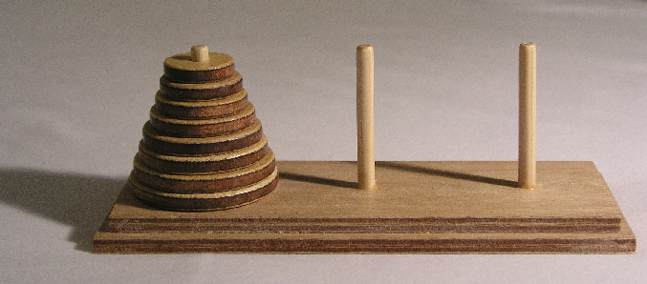

The starts off like shown in the picture with N number of plates start at Stick 1 with the smallest plates at the top and the largest ones at the bottom.

The goal is to move all the plates to another stick (so either Stick 2 or Stick 3).

To begin the game, prompt the user to enter the value of N. Tell the user to enter a number between 1 to 10 plates. The computer will be the one playing the game and moving the plates. Make sure to display which plate moves to which stick for each move.

However, there are two rules:

1) You can only move one plate at a time.

2) A bigger plate can’t be on top of a smaller plate.